Reid Jackson

CS4442 Assignment 1

Feb 16th 2020



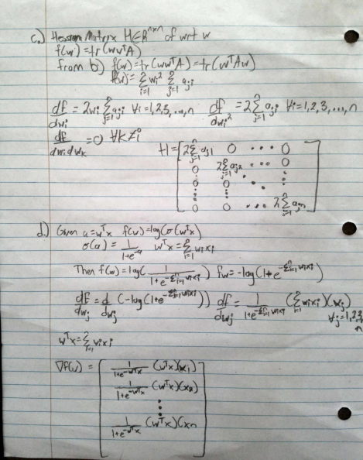

2a

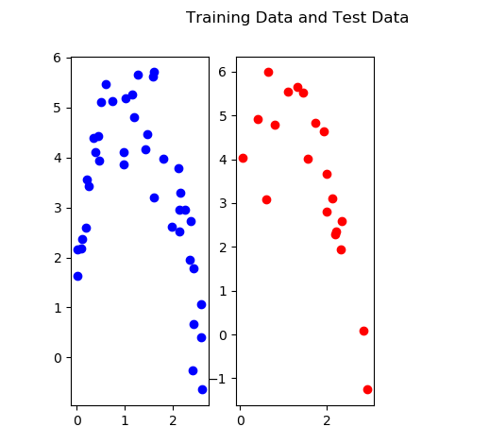

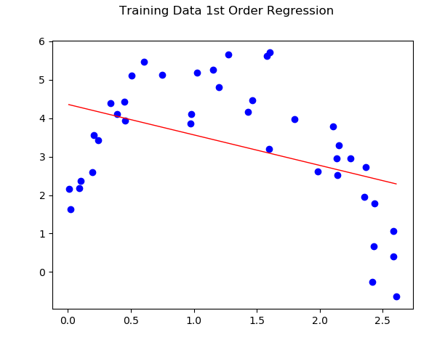2b

Equation: y = -0.79337581x + 4.35891503

Average Error = 2.17394558

2c

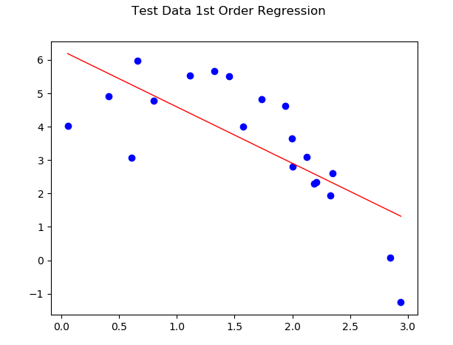

Equation: y = -0.79337581x + 4.35891503

Average Error = 1.59595861

2b and 2c Python Code

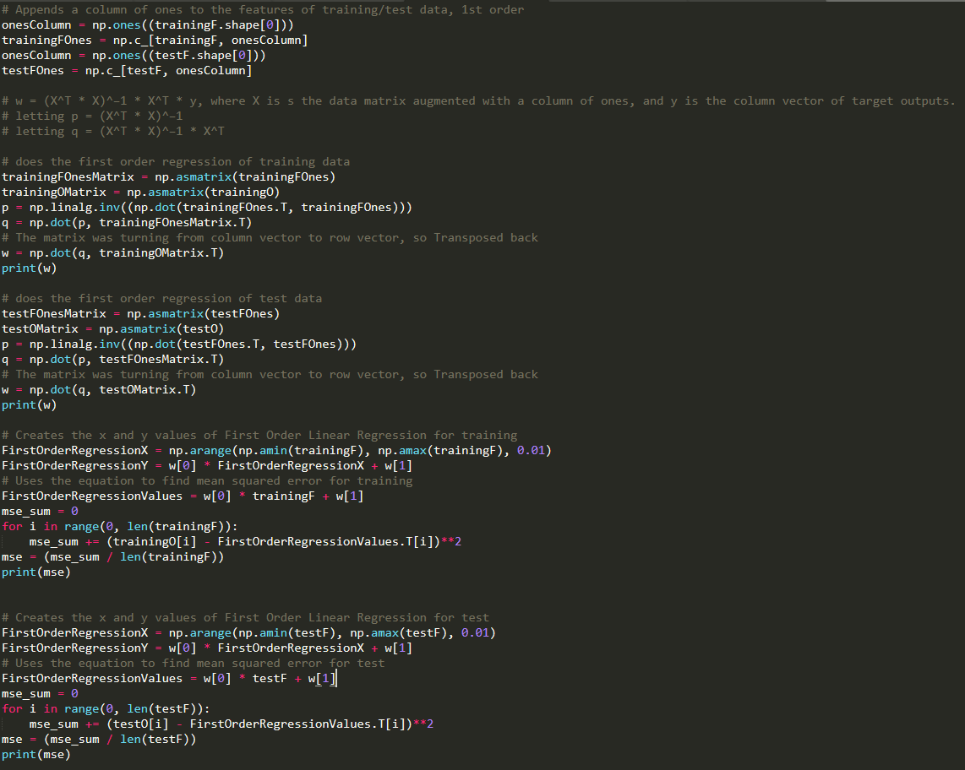

2d

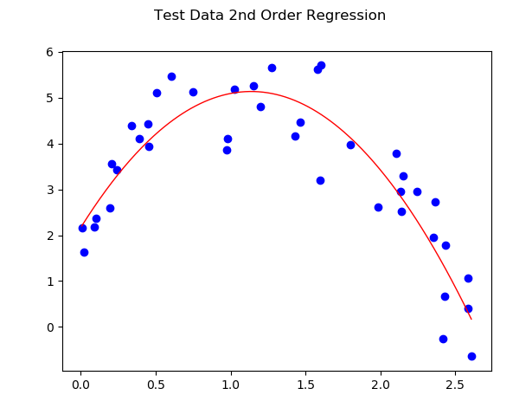

Equation: y = -2.29718151x2 + 5.22039519x + 2.16940573

Average Error = 0.4846845031271549

(also note the title is supposed to be training data)

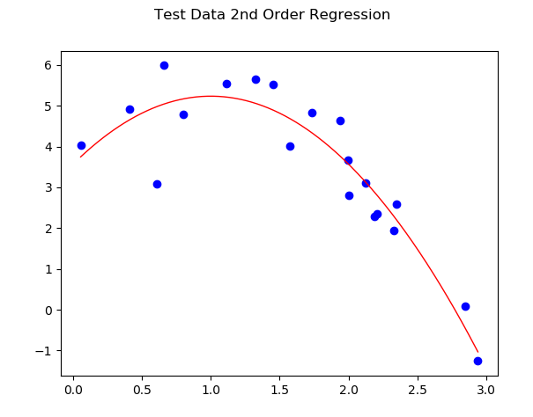Equation: y = -1.67167226x2 + 3.34520812x + 3.56132903

Average Error = 0.44645401066211254

Given the better error values for the Second-Degree Regression, this is a better fit for the data over the Linear Regression (First Order).

Python Code

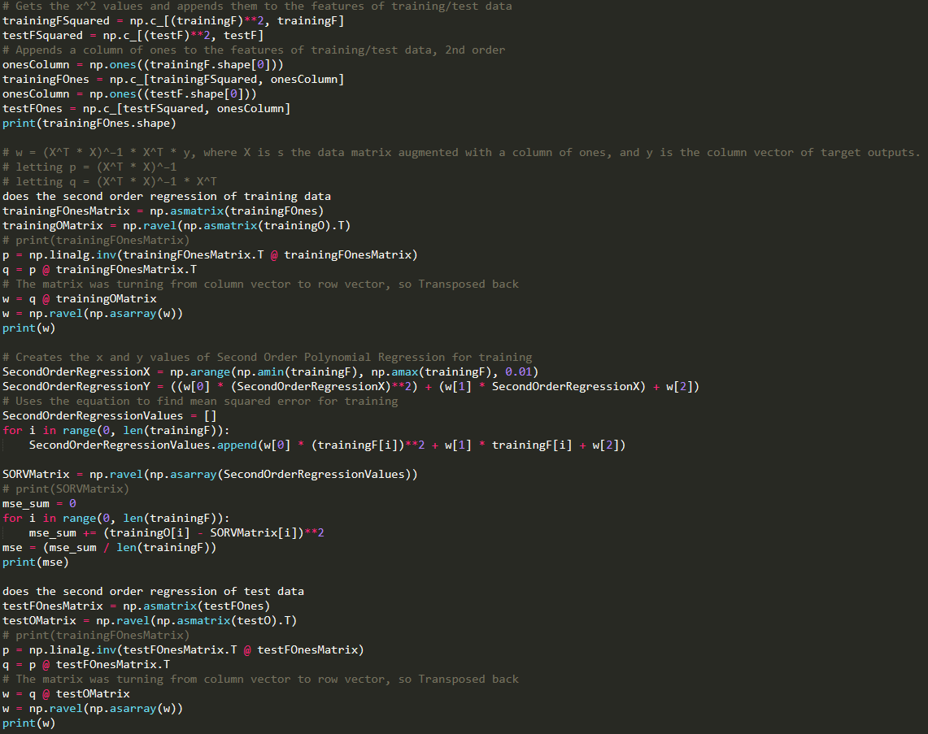

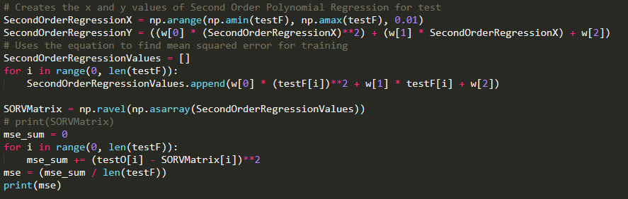

2e

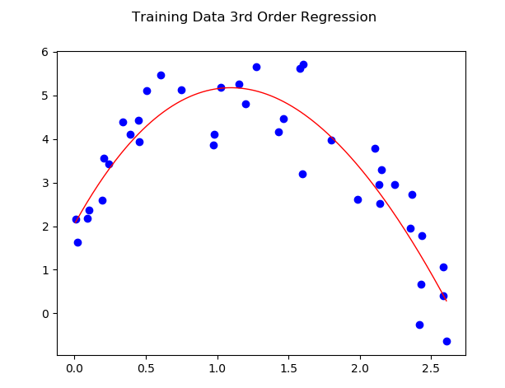Equation: y = 0.17701719x3 - 2.99261207x2 + 5.92195383x + 2.04696968

Average Error = 0.48055213344532505

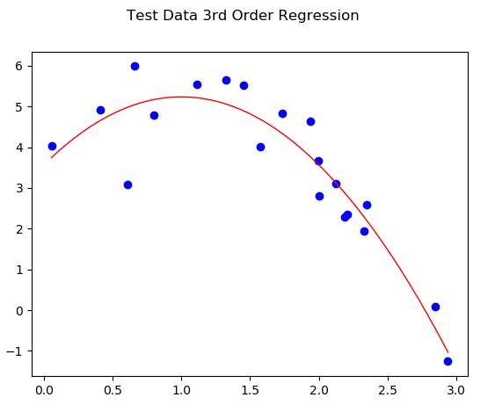

Equation: y = 1.44636153e-03x3 - 1.67845534x2 + 3.35391872x + 3.55893345

Average Error = 0.4464533911621823

Based on the average errors, there is very little difference between 2nd and 3rd Order Regressions. Though, it is still much more accurate than 1st Order.

Python Code

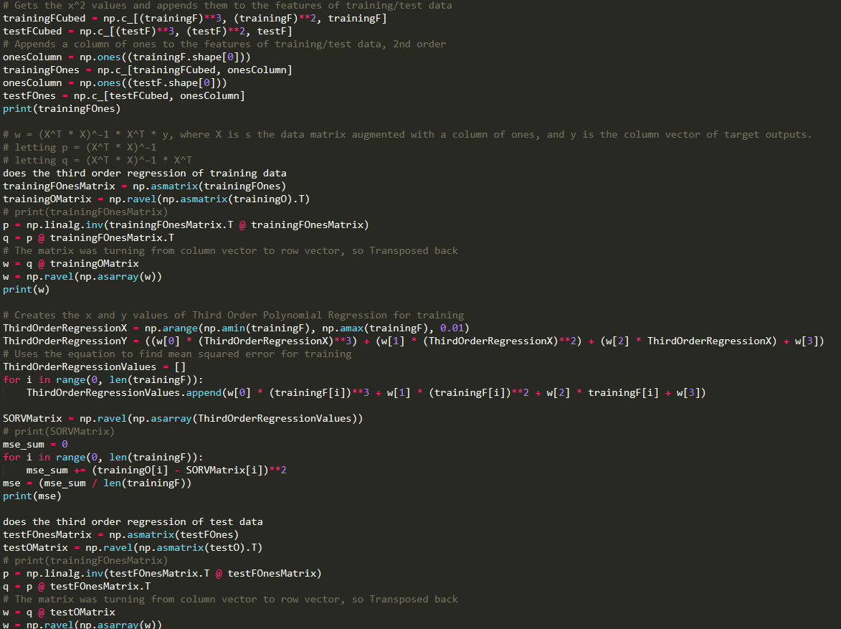

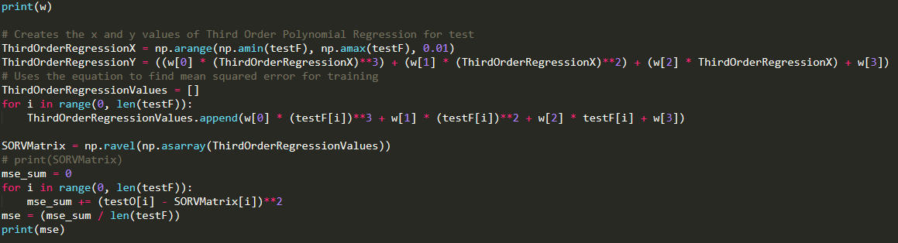

2f

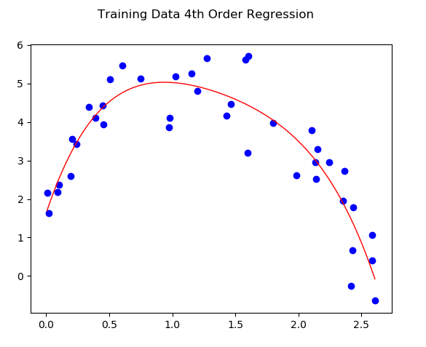

Equation: y = -0.78497416x4 + 4.29846914x3 -9.85657215x2 + 9.73054414x + 1.6375279

Average Error = 0.43664763409971397

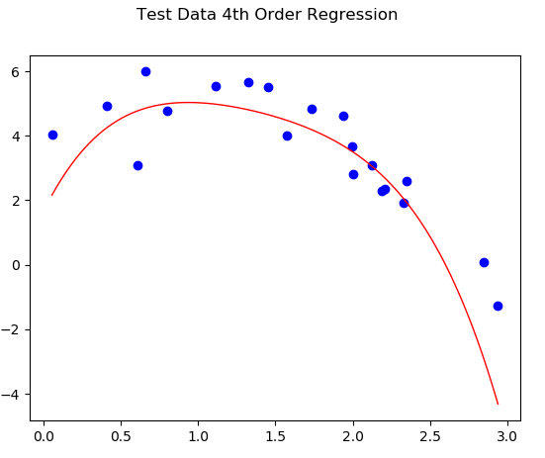Equation: y = -0.78497416x4 + 4.29846914x3 -9.85657215x2 + 9.73054414x + 1.6375279

Average Error = 1.5584694832319532

Based on all the results, the 4th Order is better than 1st order but worse than 3rd and 2nd. And the order of accuracy is 3rd Order, 2nd Order, 4th Order then 1st Order.

Python Code

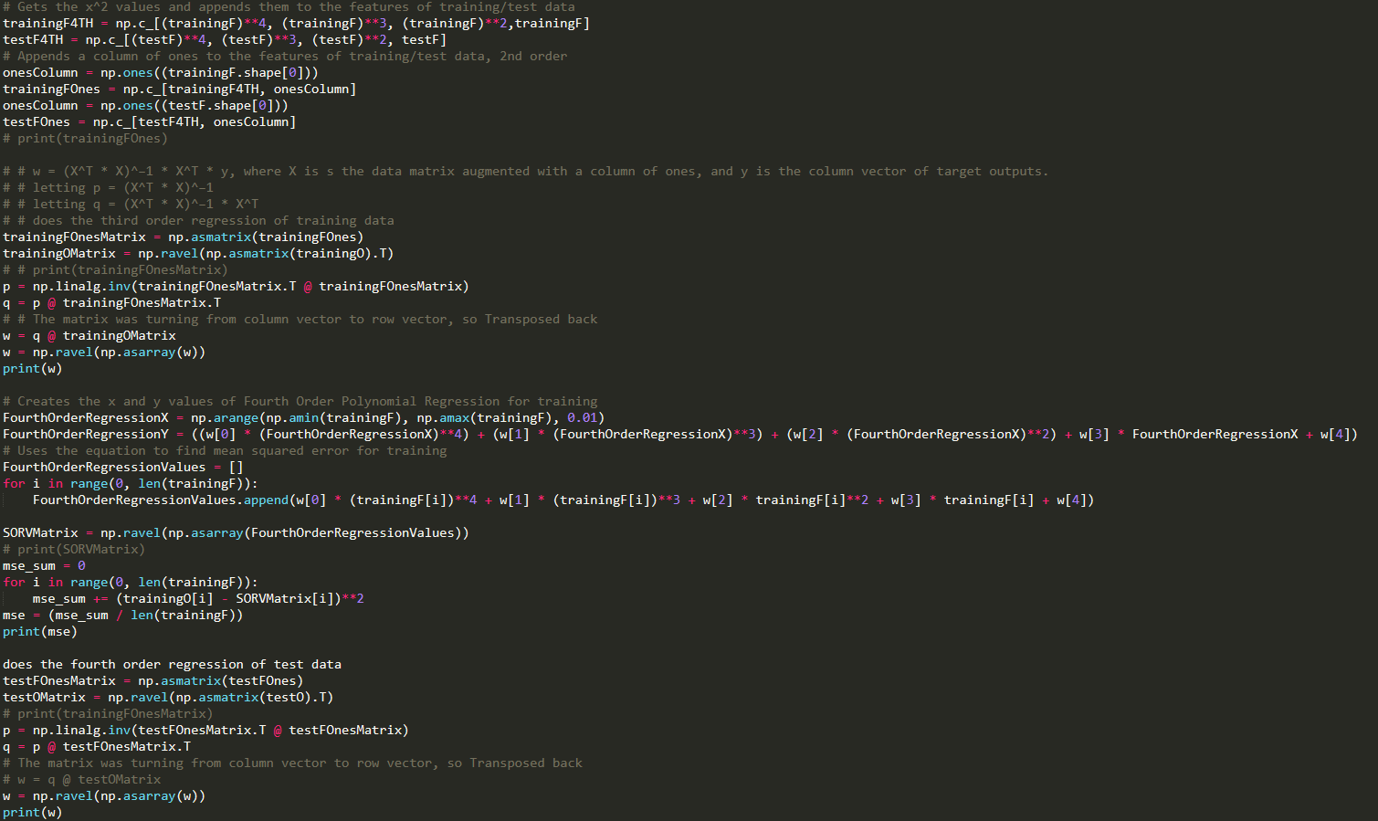

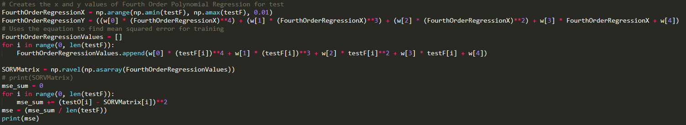

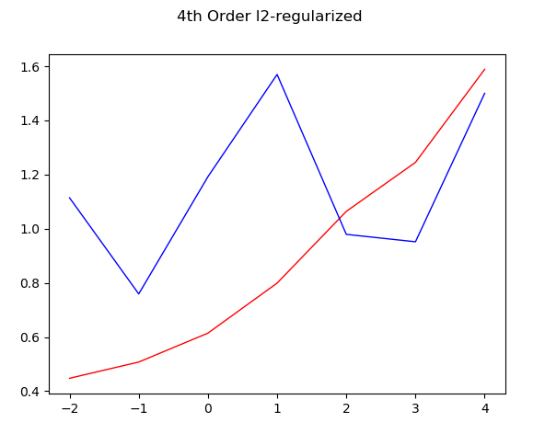3a

(Blue Line is the Error while Red is the Test Error)

From this, it can be concluded that lambda of 0.1, or lambda = e-1 gives the minimum, and is the best fitting for that data.

Python Code

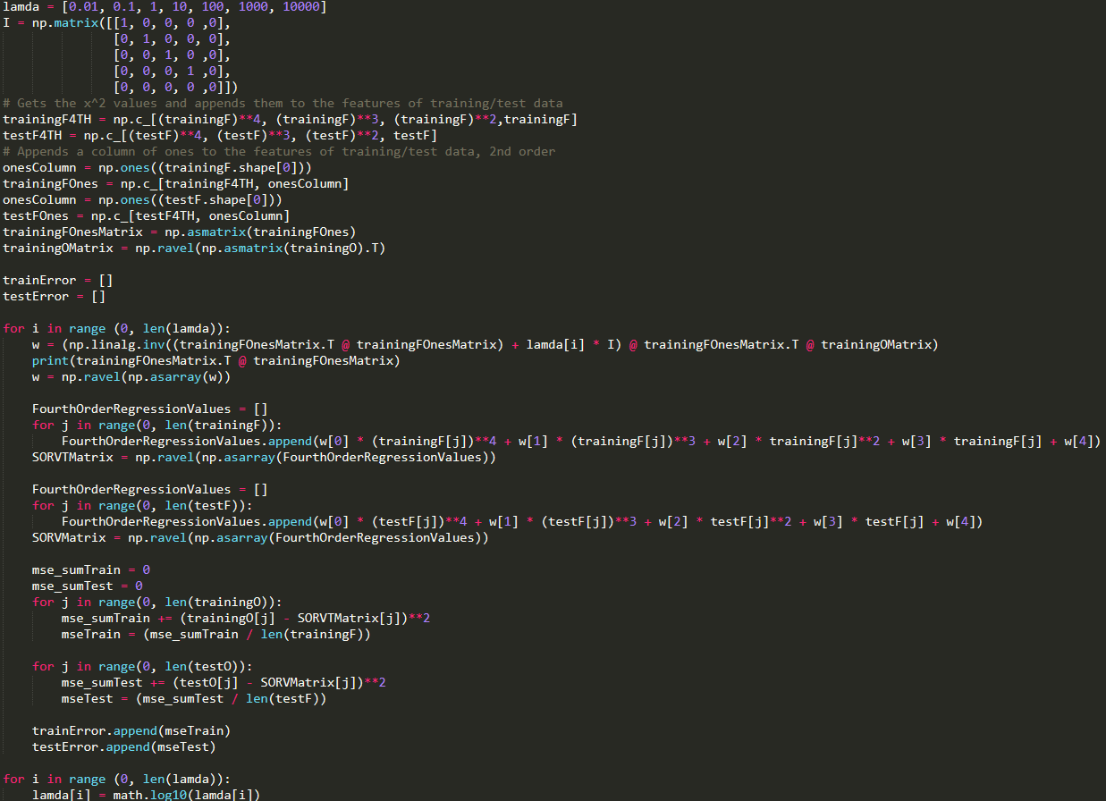

3b

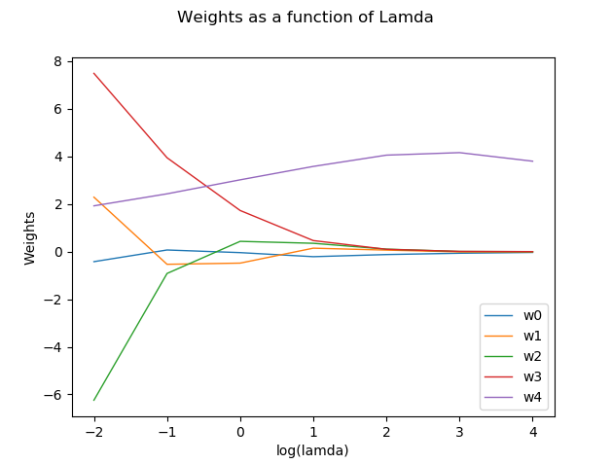

Lambda is spelt wrong here as the code interprets lambda as a preset value, lamda does not cause errors

Python Code

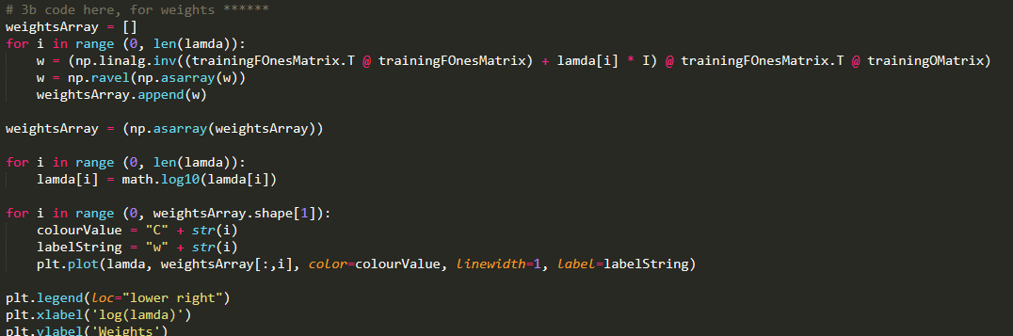

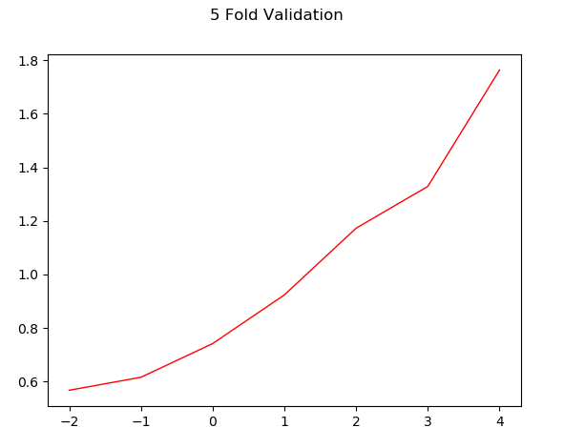3c

As this graph shows, the lambda value of   
-2 in log(lambda) is better than the previous lambda of 0, which makes lambda 0.01 instead of 0.1.

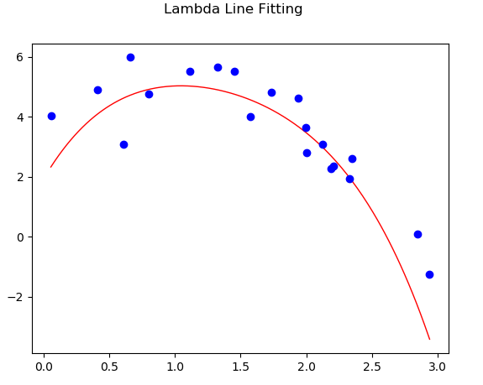

Here is the test data fit with a l2-regularized 4th-order polynomial regression line, with a lambda of 0.01.

Python Code

